Analytical Longitudinal Speed Planning for CAVs with Previewed Road Geometry and Friction Constraints
Liming Gao, Craig Beal, Daniel Fescenmyer, Sean Brennan, IEEE Member
. Abstract— Due to the lack of information, current vehicle control systems generally assume that the road friction conditions ahead of a vehicle are unchanged relative to those at the vehicle's position. However, with connectivity either to other vehicles, infrastructure, or cloud services, future vehicles may have access to this information which is particularly valuable for planning velocity trajectories ahead. This paper introduces a method for planning longitudinal speed profiles for Connected and Autonomous Vehicles (CAVs) that have previewed information about road geometry and friction conditions. The novelty of this approach is to explicitly include consideration of the friction ellipse available along the intended path to develop an analytical solution to the allowable vehicle velocity profile that prevents departure from the friction ellipse. The results further define the relationship between the friction bound, path geometry, and minimum friction preview distance that ensure the vehicle has sufficient time to take action for upcoming hazardous situations. The efficacy of the algorithm is demonstrated through an application case where a vehicle navigates a curving road with changing friction conditions at allowable and stable speeds, with results showing that the vehicle consistently operates within the available friction limits.

INTRODUCTION
Highway road conditions are reported to have a significant influence on traffic safety and mobility. Unforeseen hazardous road conditions such as snow, ice, rain, etc potentially can have a significant negative impact on vehicle safety and mobility. The Federal Highway Administration reported that approximately 20% of all crashes occur in adverse road conditions; light rain or snow can reduce average traffic flow volume by 5%-10% on the highway [1]. Conversely, efficient highway systems should ensure that vehicles travel as expediently as possible to maximize the throughput of the highway. Uncertainty about exact highway conditions creates a conflict between these two objectives, as drivers may drive too fast and experience adverse road conditions or drive more conservatively than necessary, impeding traffic flow.
Much research has been conducted to address the vehicle mobility issue in hazardous conditions. One common way is to develop Advanced Driver Assistance Systems (ADASs) such as EBS, LKA, and ESC, etc., which can assist a driver to follow the desired path stably in hazardous situations. These assistance control systems designed for the vehicle itself can be categorized into lateral control, longitudinal control, and hybrid control. Once the vehicle experiences instability, the controller can output a proper steering angle and/or driving/braking torque command to stabilize movement. For example, Yu, et al. [2] designed a feedback-feedforward steering controller to improve the vehicle stability when hard-braking maneuvers on road with split friction. Li, et al. presented a torque control strategy for the situation of abrupt changing of road friction [3].
However, most of these controllers are passively activated only when the vehicle states have a significant deviation from the nominal value. Even worse, a controller may fail to keep the vehicle stable if the road condition changes significantly and rapidly because of delays in the system and real actuator limitations.
In contrast with these control strategies that react to certain measured vehicle instabilities, researchers have also developed proactive envelope controllers which can be combined with real-time road friction estimation to keep the vehicle within a stable region bounded by road-tire friction limits. However, these systems only maintain vehicle stability from the perspective of body-fixed states and cannot prevent the vehicle from deviating from the desired path when the road condition changes significantly and rapidly.
Another method of proactively maintaining vehicle stability is to utilize longitudinal velocity planning to maintain stability when following a path with tight curvature change [4]. The idea is to reduce vehicle speed before a potentially dangerous situation is reached, in contrast with widely used stability control systems that only react once the loss of control is imminent. The reason why speed control is effective is that the vehicle has a larger stable operating region to follow the desired path with a smaller velocity [4][5].
However, previously published longitudinal velocity planning approaches consider only the variation of path curvature, and little attention has been paid to the road surface friction condition changing when conducting longitudinal velocity planning. Research has proved that the prior estimation of friction and peak tire force before the slick region is reached, allows a vehicle chassis control system to work more reliably and proactively [2]. As a result, if the vehicle can preview the path friction reduction and slow down appropriately before entering the slick region, even a simple driving algorithm can operate the vehicle to follow the desired path well.
Although each vehicle on a roadway can constantly measure and navigate the world using its in-vehicle systems, it is almost impossible for an individual vehicle to preview the road condition for its entire trip. One potential solution to preview the road surface friction condition is motivated by the increasing research into cyber-physical systems, especially Connected and Autonomous Vehicles (CAVs). This solution takes advantage of both network intelligence and individual intelligence, where road friction information [7][8] from the individual vehicles and roadside sensor units is shared within the network. Within the network, the information can flow between vehicle to vehicle, vehicle to infrastructure, and vehicle to database systems. In this way, each vehicle in the network can query the aggregated friction information from the shared database. An illustration of this network framework is shown in Fig. 1. It is anticipated that in the future, a vehicle enhanced by the network intelligence could move reliably even without an advanced ADAS.
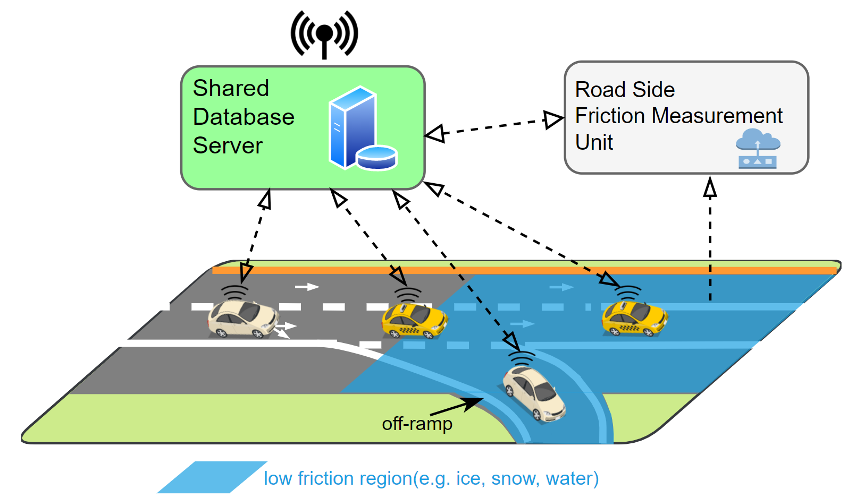
Figure 1. A strategy of road friction and geometry preview with a shared roadway database. The shared database can leverage network intelligence to substantially improve the operation of each individual in the population.
The desired improvements in vehicle safety and mobility can be achieved by limiting the vehicle speed based on the previewed road condition. In this paper, an idea of road friction preview through database-informed CAVs is introduced. Then inspired by the work of various authors on vehicle dynamics at the limits of handing [9]–[11], we present an algorithm to generate a longitudinal vehicle velocity limit profile for a given desired path that takes into account local speed limits, road geometry, and current road friction conditions. Closed-form analytical formulae are established for certain common preview cases, allowing for the introduction of a straightforward and computationally efficient algorithm for generating the velocity profile. Furthermore, relationships are established between path low friction bound, path geometry, and minimum friction preview distance that ensure the vehicle has sufficient time to take action for upcoming hazardous situations.
The remainder of this paper is organized as follows: Section II discusses the velocity limit profile planning based on the road-tire friction limits and road geometry. Section III analyzes the friction preview distance. Section IV demonstrates the approach with an application case. Finally, Section V summarizes the main results of the work and anticipated future work.

Vehicle Longitudinal Velocity Planning Given a Reference Path
This section presents the generation of a limit speed profile that vehicles can achieve without exceeding available tire friction limits constraints. The section begins by deriving the constraints of driving on the friction circle by controlling the vehicle longitudinal dynamics, and then introduces an approach to describe a driving path by station s, curvature κ, and friction coefficient μ. Finally, the section concludes with the details of the velocity planning method.

A. Vehicle Chassis Model and Tire Friction Limits
The vehicle dynamic equations for the three states single track model shown in Fig. 2 are:
where longitudinal velocity U_{x}, lateral velocity U_{y}, and yaw rate r are the three states. θ is the path grade, and g is the gravitational acceleration. The vehicle parameters include the vehicle mass m, yaw moment of inertia I_{zz}, front wheel steering angle δ, and a and b the distances from the vehicle’s center of gravity to the front and rear axle respectively. F_{xf}, F_{xr}, F_{yf}, F_{yr} are the longitudinal and lateral forces acting on the front and rear tires.
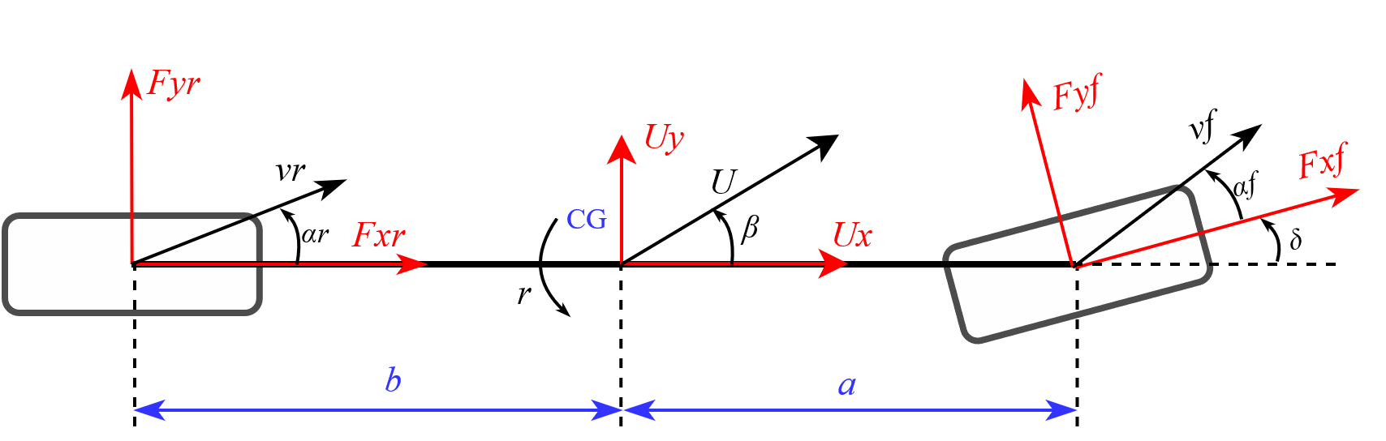
Figure 2. Planar single-tack vehicle chasis model
The maximum available longitudinal force F_{x} and lateral force F_{y} at each tire is constrained by a circular friction constraint:
where μ is the road-tire friction coefficient, and F_{zf} and F_{zr} are the vertical force at the front and rear axle respectively. Ignoring the effects of lateral and longitudinal load transfer, the vertical forces are, .
Determining the limit speed profile requires the vehicle to utilize all the available tire friction to generate forces so that vehicle can operate at the acceleration limits to achieve the maximum safe speed [12], [13]. It implies that all tire forces need to remain on the boundary of the friction circle, i.e. equality holds in .
Fig. 3 shows the road-tire force when maneuvering through a left corner of a path at the tire limits. The boundary of the friction circle depends on the road-tire friction coefficient.
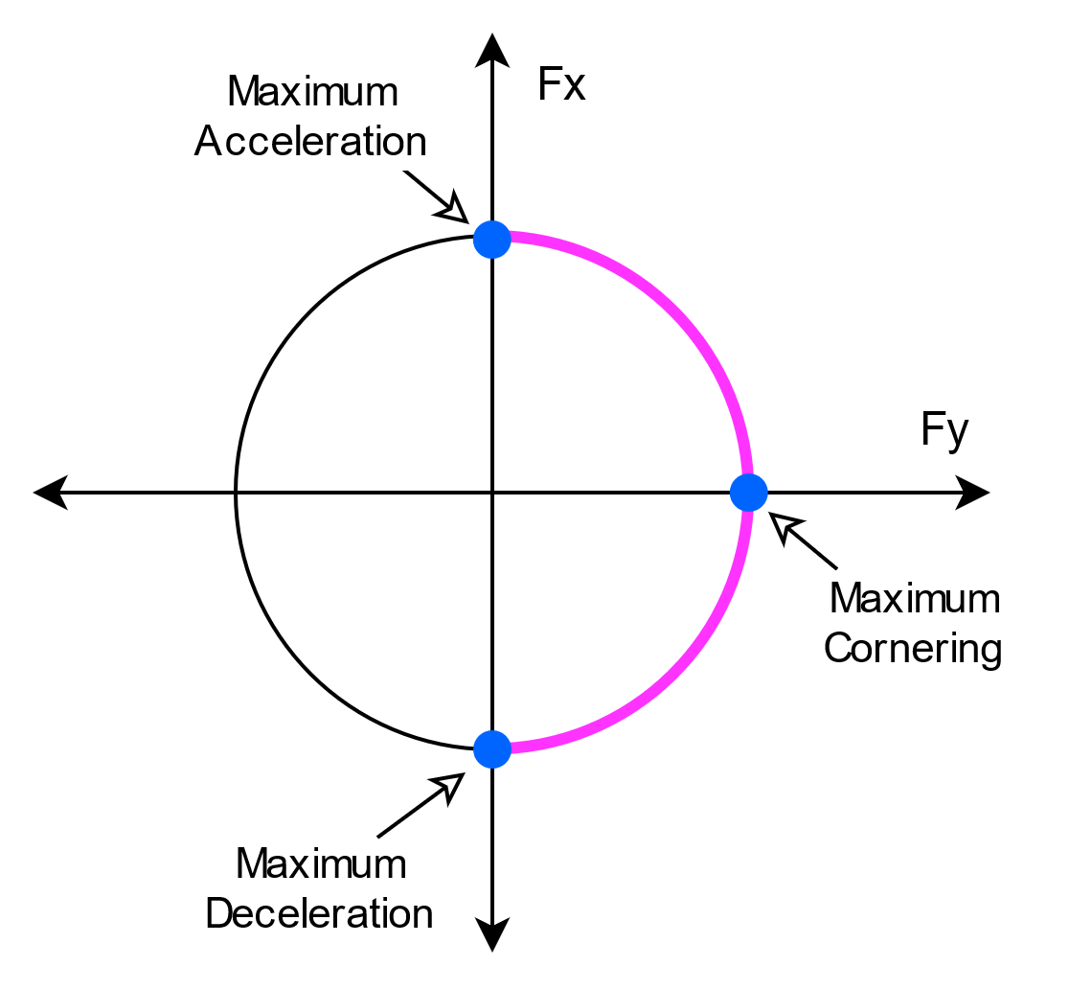
Figure 3. The maximum performance of vehicle can be achieved by driving at the boundary of friction circle. This plot shows the left cornering case.
As this work is interested in the longitudinal dynamics of a vehicle traveling stably along a path, the lateral and rotational state derivatives are assumed to be zero with quasi-steady values of the lateral and rotational velocities dictated by the road geometry:
where κ is the path curvature.
Substituting with equality condition, and into , , and yields:
a first version of the key equation governing the longitudinal speed while operating at the friction limits on a path of known curvature. Before going further, an adjusting parameter λ is added into the equation . This parameter allows for compensation of the uncertainty of friction preview and the fact that most drivers may not be comfortable with or able to operate a vehicle at the friction limits as racing drivers or autonomous driving systems might [14]. Consequently, the dynamics equation that depicts the maximum available longitudinal acceleration is expressed as:
where the plus-minus sign (±) corresponds to acceleration and deceleration respectively. Positive θ corresponds to upgrades and negative is for downgrades. The parameters μ and κ in depend on the path position, which is introduced in the following section.

B. Path Representation
In contrast to many publications that describe the process of path planning for minimal time or maximal speed within the boundaries of a road or track, this paper instead focuses on following a given path. Specifically, the emphasized use is for following the lane centerline of a given highway with occasional vehicle-planned lane changes. Therefore, the desired path is assumed to be known. The clothoid path description is widely used for highway road design [15] and vehicle path planning, for example, the racing line [16], [17] and minimum curvature optimal path [18],[19]. A clothoid path can generally be described by a succession of turns - consisting of spirals and constant radius arcs - and straight lines. The spiral segments are defined to have linearly increasing or decreasing curvature along the path:
where s referred to as “station” in this paper, is the distance measured along a path; L_{s} is the total length of the spiral and κ_{c} is the curvature at the end of the spiral. In this way, the curvature of the whole path can be described by a succession of linear functions.
Without loss of generality, an example oval path similar to the Larson Institute Test Track [20] is shown in Fig. 4. The path is given according to the highway road design rule which decomposes the corner into three phases: an entry clothoid, a circular arc, and an exit clothoid [16]. The corresponding curvature, along with the road grade and a hypothetical friction profile, are shown in Fig. 5. All of these path parameters can be described as a function of the path station: κ(s), μ(s), θ(s). The portions of the path where the grade is non-zero was chosen to be similar to the off-ramp and on-ramp part of a highway

C. Velocity Profile Generation
Velocity planning has a significant impact on driving safety, especially when vehicles drive on a road with changing friction and geometry. With the longitudinal dynamic equation and the desired path description, the speed profile can be determined. The approach presented in this paper is inspired by previous work that addressed the profile determination via three passes [13], nonlinear optimization [4], and segment and iteration [21], where a velocity profile is planned given the path curvature.
Figure 5. The curvature, previewed friction coefficient, and previewed grade for the sample path. The friction is assumed to change abruptly.
The first step of the approach is to express the longitudinal acceleration with respect to the vehicle station:
Substituting into yields:
A closed-form solution for can be found for line segment and arc path cases, which generally account for a significant portion of a path.
For the straight line segment with constant friction, the solution of is:
where U_{x_l0} is the initial speed condition.
For the zero-grade radius arc path whose curvature and friction coefficient are a constant, can be solved analytically:
where is a parameter depending on the initial speed condition U_{x_a0}.
For the spiral and arc path with non zero grade, a Taylor series approximate solution of can be found [22]:
where a₀=U_{x_s0} is the initial speed condition, and a₁, a₂, a₃, a₄ can be explicitly expressed as the function of a₀, μg, κ,θ. To evaluate the error, the approximation results for a spiral sample are compared with the numerical solution using the Runge-Kutta (4,5) formula. (This approximation is only convergent locally, so I decide to use a numerical solution for spiral for this paper. We may find a better approximation later)
For spiral and arc path with a non-zero grade, can be solved using a numerical Runge-Kutta (4,5) method which is more accurate than Euler’s method used by many researchers for a similar problem [13].
Based on the solution analysis above, the first step of generating the speed profile is to divide the given path into piecewise segments with linear or constant curvature and constant friction and grade. Then we can piecewise conduct the speed planning.
The second step is to piecewise find the maximum permissible steady-state vehicle velocity with zero longitudinal acceleration, which is given by :
Notice that the steady-state speed will be very high when the curvature is small (the curvature is zero, yielding an infinite maximum curve speed for a straight line) and thus a speed limit of 50m/s was imposed. λ=0.95 is also chosen to explore the vehicle behavior close to the friction limits. This step result is shown as the “curve limit speed” in Fig. 6(a).
The following next step is a forward speed limit calculation step. It starts from the first segment with the initial speed at s = 0. Then for each following segment, conduct the speed planning using , or numerical method, where the initial speed is determined by the previous segment. A key point of this step is that the speed result at each segment is compared to the curve limit speed, and the minimum value is taken. This step indicates how fast a vehicle can accelerate shown as the “Forward limit” in Fig. 6(a).
Next, the backward speed limit calculation occurs. It starts from the last path segment and takes the desired vehicle speed at the end of the path as the initial speed condition. Then calculate the speed profile for each following segment until back toward to first path segment. The result at each segment is also compared to the curve limit speed and takes the minimum. This step indicates how fast a vehicle can decelerate shown as the “Backward limit” in Fig. 6(a).
Finally, the minimum of “Backward limit” and “Forward limit” is used as the final speed profile shown as the “combined results” in Fig. 6(a).
Figure 6. (a) The intermediate and final results of the speed profile of the computation algorithm. (b) The acceleration of the speed profile.
₌
The corresponding acceleration profile is shown in Fig. 6 (b) indicating that the total acceleration
is bounded by the friction limit and road grade
Additionally, note that the acceleration value is as large as a racing car especially at the large friction region, but the acceleration value can be tailored by choosing a proper adjusting parameter λ.
Figure XX. numerical and polynomial solutions for spiral curves showing that the analytical solution agrees. with length 100m, Rc = 200,
In summary, the feasible speed trajectories and associated preview are determined as follows:
- Given a path with position and curvature κ. The corresponding friction μ and grade θ are found far ahead of the vehicle, much farther than the possible minimum look-ahead distance. These values are assumed to be stored either on the vehicle or obtained in advance via V2x communication. In the examples that follow, 2.1 km is used.
- Break the path ahead of the vehicle into a piecewise segment according to the curvature, friction, and grade.
- The curve limit speed is found for each segment as calculated by .
- Starting at s=0 and stepping in the forward direction, the possible change in speed is calculated using , or numerical method such that the friction ellipse is not violated in the forward direction.
- Next, starting at s = s_final and stepping in the reverse direction, the change in speed is calculated from , or numerical method such that the friction ellipse is not violated in the backward direction.
- The minimum speeds from steps 4 and 5 are used as the final limit speed.

Minimum Friction Preview Distance
Examining Fig.6, one can see that the speed profile calculated at each station requires information ahead of the station, but the distance ahead changes at each station depending on conditions. For example, to correctly calculate the velocity limits at station A, the path information at station B (124m ahead of A) must be known and similarly, the determination of speed limit at C even requires the information at location D (590 m ahead of C). We call this information window distance the minimum preview distance.
Examining Fig.6 again, the preview information is only required at the path region where the combined speed profile is lower than the curve limit speed profile. With this observation, the preview region can be extracted from the speed profile, and thereby the minimum preview distance at each station can be calculated easily. Fig.7. presents the results for the sample path in Fig.4. It can be observed that the preview distance at station C is large obviously due to that station C is a position approaching a high curvature and low friction region.
When friction information is collected via a system outside the vehicle, for example, a shared database, the use of an appropriate preview distance is important to prevent unnecessary transmission of large amounts of data. Longer preview distances involve more data transmission, resulting in more time delay and data cost, but an overly short preview distance could lead to a situation where a vehicle might not have enough space to respond to the dangerous situation ahead. Therefore, the database or the vehicle should be able to host algorithms that calculate the minimum preview horizon.
Figure 7. The minimum preview distance for sample-path with changing friction of Fig. 4.
In application, the preview distance needs to be determined before querying friction data from a database. And constant low friction bound can be assumed for the determination. For example, driving during adverse weather such as rain and snow, lower road friction bound is expected; but driving a clear sunny day, the friction bound should be larger.
The dependence of preview on friction is shown in Fig. 8 where different friction assumptions yield different preview curves. The results reveal that the preview distance changes considerably versus the road friction values and the road curvature. It can be seen that less preview distance is required with higher confident road friction bound.
For example, for curve-keeping, a straight road would not require any preview.
Figure 8. The minimum preview distance versus station and low friction bound for sample-path shown in Fig. 4.
This section presents methods for determining the minimum friction preview distance for different situations: maximum velocity preview distances (e.g., the results of the prior sections), or even the preview distances needed to achieve braking to a complete stop.
V_max =31m/s (post speed limit, find zero preview distance. ) design friction is going to be about 0.1. For real highway, the preview distance should be almost zero unless the friction is very very low.

An interesting result of this work is the finding that many roads are designed such that there is a minimum friction value for operation such that, if actual friction values are above this value, then no preview is needed for maintaining the speed limits.
For comparison, most human drivers with the required driving vision can only see the road approximately 500m ahead, even on a clear day [ref]. This visibility is also reduced significantly during darkness and adverse weather, such as fog, rain, and snow, where hazardous road friction conditions often occur. The driver’s sight is further limited by road geometry such as corners and crests of hills. Thus, the preview of road friction and geometry could provide significant benefit for drivers to adjust their driving speed proactively.

Application Case and Simulation Results
This work presents an application case to demonstrate the efficacy of velocity profile planning. In this case, a vehicle follows the path shown in Fig. 4 with the hypothetical station-dependent friction conditions given in Fig. 5.
In open-loop driving with the vehicle on a low-friction curve, drivers are often unable to stabilize the vehicle. But with the preview of path friction and geometry, a speed controller can plan the velocity profile to prevent the vehicle from excess speed in a curve and thereby preventing poor trajectory tracking or even road departure.
A driver model is used based on the assumption that a driver intends to look ahead with a 20m preview horizon when tracking the desired path. The 7-DOF rear-driving and front steering vehicle model is used for the simulation. Use adjusting parameter λ=0.4 for the rear driving feature and a non-aggressive driver style. The controller can follow the path well with the preview of friction and speed.
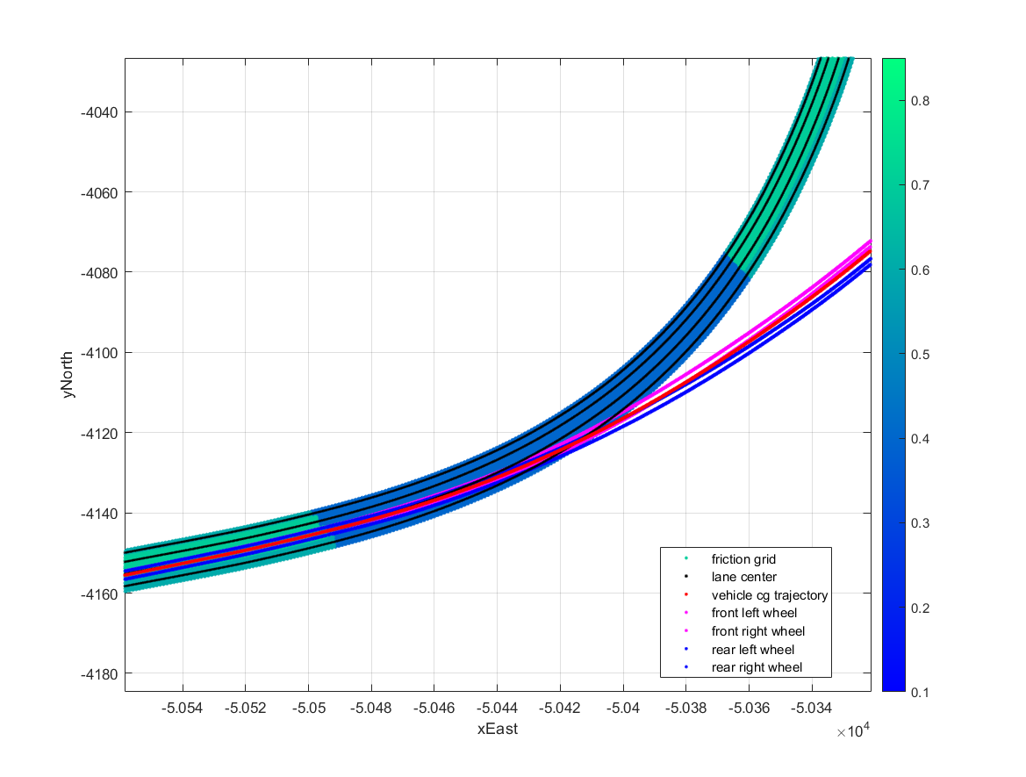
Figure 10. (this plot is just an example, a correct one will be added) The lateral tracking error for the situation with and without friction preview is evident, showing that the vehicle can track the desired trajectory with much less lateral error with friction preview.

Conclusion
This paper has introduced a method for planning longitudinal speed profiles for CAVs that have previewed information about road geometry and friction conditions. The idea of preview is to extend individual intelligence with network intelligence. The longitudinal speed planning is enabled by solutions to the allowable velocity profile that prevents departure from the friction ellipse with closed-form analytical results in certain cases. The results further define the relationship between the minimum preview distance and longitudinal velocity limits that ensure the vehicle has sufficient time to take action for upcoming hazardous situations. The efficacy of the algorithm is demonstrated through an application case where a vehicle navigates curvy roads with changing friction conditions at maximum speeds.

Acknowledgment
This material is based upon work supported by the National Science Foundation under grant no. CNS-1932509 CNS-1931927, CNS-1932138 “CPS: Medium: Collaborative Research: Automated Discovery of Data Validity for Safety-Critical Feedback Control in a Population of Connected Vehicles”.

References
[1] A. F. Highway, “How Do Weather Events Impact Roads?,” 2020. https://ops.fhwa.dot.gov/weather/q1_roadimpact.htm.
[2] L. Yu, S. Zheng, Y. Dai, L. Abi, X. Liu, and S. Cheng, “A feedback-feedforward steering controller designed for vehicle lane keeping in hard-braking manoeuvres on split-μ roads,” Veh. Syst. Dyn., 2021, doi: 10.1080/00423114.2020.1869274.
[3] L. Li, “PID PLUS FUZZY LOGIC METHOD FOR TORQUE CONTROL IN TRACTION CONTROL SYSTEM,” Int. J. Automot. Technol., vol. 13, no. 3, pp. 441–450, 2012, doi: 10.1007/s12239.
[4] H. Cao, X. Song, S. Zhao, S. Bao, and Z. Huang, “An optimal model-based trajectory following architecture synthesising the lateral adaptive preview strategy and longitudinal velocity planning for highly automated vehicle,” Veh. Syst. Dyn., vol. 55, no. 8, pp. 1143–1188, 2017, doi: 10.1080/00423114.2017.1305114.
[5] C. E. Beal and C. Boyd, “Coupled lateral-longitudinal vehicle dynamics and control design with three-dimensional state portraits,” Veh. Syst. Dyn., vol. 57, no. 2, pp. 286–313, 2019, doi: 10.1080/00423114.2018.1467019.
[6] C. G. Bobier-Tiu, C. E. Beal, J. C. Kegelman, R. Y. Hindiyeh, and J. C. Gerdes, “Vehicle control synthesis using phase portraits of planar dynamics,” Veh. Syst. Dyn., vol. 57, no. 9, pp. 1318–1337, 2019, doi: 10.1080/00423114.2018.1502456.
[7] S. Roychowdhury, M. Zhao, A. Wallin, N. Ohlsson, and M. Jonasson, “Machine Learning Models for Road Surface and Friction Estimation using Front-Camera Images,” in 2018 International Joint Conference on Neural Networks (IJCNN), 2018, pp. 1–8, doi: 10.1109/IJCNN.2018.8489188.
[8] C. E. Beal, “Rapid Road Friction Estimation using Independent Left/Right Steering Torque Measurements,” Veh. Syst. Dyn., vol. 58, no. 3, pp. 377–403, 2020, doi: 10.1080/00423114.2019.1580377.
[9] J. Subosits and J. C. Gerdes, “Autonomous vehicle control for emergency maneuvers: The effect of topography,” Proc. Am. Control Conf., vol. 2015-July, pp. 1405–1410, 2015, doi: 10.1109/ACC.2015.7170930.
[10] K. Kritayakirana and J. C. Gerdes, “Autonomous vehicle control at the limits of handling,” Int. J. Veh. Auton. Syst., vol. 10, no. 4, pp. 271–296, 2012, doi: 10.1504/IJVAS.2012.051270.
[11] J. Ni, J. Hu, and C. Xiang, “Envelope Control for Four-Wheel Independently Actuated Autonomous Ground Vehicle Through AFS/DYC Integrated Control,” IEEE Trans. Veh. Technol., vol. 66, no. 11, pp. 9712–9726, 2017, doi: 10.1109/TVT.2017.2723418.
[12] W. C. Mitchell, R. Schroer, and D. B. Grisez, “Driving the traction circle,” SAE Tech. Pap., no. 724, 2004, doi: 10.4271/2004-01-3545.
[13] N. R. Kapania, J. Subosits, and J. C. Gerdes, “A Sequential Two-Step Algorithm for Fast Generation of Vehicle Racing Trajectories,” J. Dyn. Syst. Meas. Control. Trans. ASME, vol. 138, no. 9, 2016, doi: 10.1115/1.4033311.
[14] C. E. Beal and J. C. Gerdes, “Model predictive control for vehicle stabilization at the limits of handling,” IEEE Trans. Control Syst. Technol., vol. 21, no. 4, pp. 1258–1269, 2013, doi: 10.1109/TCST.2012.2200826.
[15] AASHTO, A Policy on Geometric Design of Highways and Streets. 2018.
[16] P. A. Theodosis and J. C. Gerdes, “Nonlinear optimization of a racing line for an autonomous racecar using professional driving techniques,” in ASME 2012 5th Annual Dynamic Systems and Control Conference Joint with the JSME 2012 11th Motion and Vibration Conference, DSCC 2012-MOVIC 2012, 2012, vol. 1, pp. 235–241, doi: 10.1115/DSCC2012-MOVIC2012-8620.
[17] P. A. Theodosis and J. C. Gerdes, “Generating a racing line for an autonomous racecar using professional driving techniques,” ASME 2011 Dyn. Syst. Control Conf. Bath/ASME Symp. Fluid Power Motion Control. DSCC 2011, vol. 2, pp. 853–860, 2011, doi: 10.1115/DSCC2011-6097.
[18] J. Villagra, V. Milanés, J. Pérez, and J. Godoy, “Smooth path and speed planning for an automated public transport vehicle,” Rob. Auton. Syst., vol. 60, pp. 252–265, 2012, doi: 10.1016/j.robot.2011.11.001.
[19] H. A. Hamersma and P. S. Els, “Longitudinal vehicle dynamics control for improved vehicle safety,” J. Terramechanics, vol. 54, pp. 19–36, 2014, doi: 10.1016/j.jterra.2014.04.002.
[20] “Test Track.” https://www.larson.psu.edu/about/test-track.aspx (accessed Apr. 08, 2021).
[21] R. Solea and U. Nunes, “Trajectory planning with velocity planner for fully-automated passenger vehicles,” IEEE Conf. Intell. Transp. Syst. Proceedings, ITSC, pp. 474–480, 2006, doi: 10.1109/itsc.2006.1706786.
[22] R. Barrio, “Performance of the Taylor series method for ODEs/DAEs,” Appl. Math. Comput., vol. 163, no. 2, pp. 525–545, 2005, doi: 10.1016/j.amc.2004.02.015.

Liming Gao is a graduate student in Mechanical Engineering at The Pennsylvania State University, University Park, PA 16802, USA (e-mail: lug358@ psu.edu). Craig Beal is with Department of Mechanical Engineering, Bucknell University, Lewisburg, PA 17837, USA (e-mail: cbeal@bucknell.edu) Daniel Fescenmyer is a undergraduate student in Mechanical Engineering at The Pennsylvania State University, University Park, PA 16802, USA (e-mail: dzf5248@psu.edu). Sean Brennan is with the Department of Mechanical Engineering, The Pennsylvania State University, University Park, PA 16802, USA (e-mail: sbrennan@psu.edu). IEEE Member.

